**18 YEPEZ CHANDI, CHRISTOPHER DANIEL**

Find One Trucks

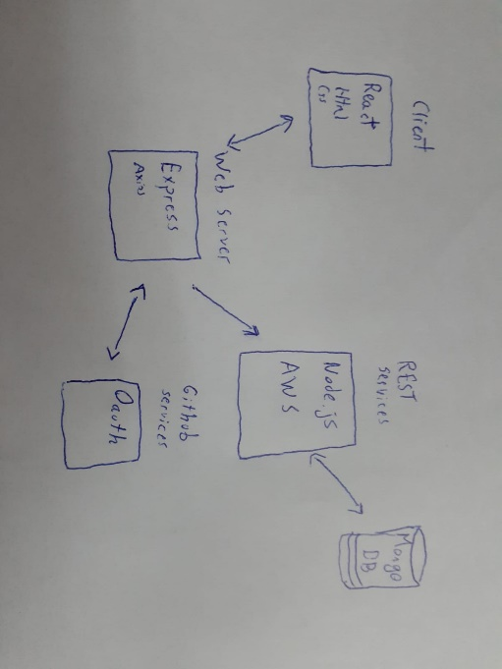

|  |  |
| --- | --- |
| **URI** | 3.82.230.29:3018/trucksforlife/trucks/{id} |
| **METHOD** | GET |
| **REQUEST** |  |
| PARAMS | id : Number |
| BODY | N/A |
| TYPE | N/A |
| **RESPONSE** | **200 OK** |
| PARAMS | N/A |
| BODY | Truck: {  id: number,  model: String,  price: Number,  isAvailable: Boolean  }  Where trucks.id = trucks.id |
| TYPE | JSON |
| **DESCRIPTION** | This Uri returns an specific truck by id from the database |

